Specific Heat Capacity Lab Name_________________________ Per _____

Specific heat (represented by C_{p}) of a substance is the heat energy necessary to raise the temperature of one gram of the substance by one Kelvin or one degree Celsius. The heat added or taken from a substance is represented by q = C_{p} * m * ΔT. Here q is heat in joules, C_{p} is specific heat, m is mass in grams, and ΔT is the change in temperature in either Kelvins or degrees Celsius. Heat is measured by calorimetry, where the change in temperature of a known mass of a substance is measured in an insulated environment. In this lab we will use calorimetry to compare the impact of a specific exchange of heat on the ΔT of water and ΔT of an ”unknown” metal sample. We will then use this data to calculate a value of specific heat as a way of identifying the metal.

Materials: Styrofoam cups w/insulated lid, 2 thermometers, crucible tongs, metal bowl, ice water, metal samples

Procedure

- Determine an accurate mass for your sample of metal. Note the observable physical properties of the metal.

2) Gently put your metal sample into ~ 250 mL of water in the metal bowl (enough to cover the metal block), and heat this to boiling on a hot plate. Monitor the water temperature with a glass thermometer.

3) Assemble a calorimeter using double Styrofoam cups with a Styrofoam cover. Insert the second glass thermometer through the cover.

4) Place the Styrofoam cups on a scale and tare it. Then measure ~50.00 g (~ 50 mL) (record exact mass!) of ice water into the cups, cover the cups with the Styrofoam lid and attached thermometer and allow the temperature to settle. Record the temperature and the exact mass of the ice water.

5) Wait until the water in the metal bowl has been boiling at a stable temperature for 2-5 minutes with the metal sample. Record the temperature of the boiling water. Grasp the metal sample firmly with your crucible tongs, and quickly transfer it to the calorimeter, put the top with the thermometer back in place, and begin observing and recording the temperature of the water in the calorimeter.

6) Record the temperature of the water in the calorimeter every 30 seconds until you have recorded the same value 4 times in a row, or until the temperature starts to fall.
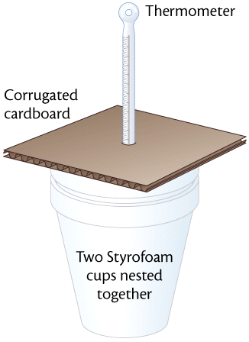
Material | Specific heat, C_{p} | Material | Specific heat, C_{p}
Aluminum | 0.895 | Silver | 0.233
Brass | 0.380 | Stainless Steel | 0.510
Copper | 0.387 | Zinc | 0.386
Gold | 0.129 | Granite | 0.803
Iron | 0.448 | Air | 1.00
Lead | 0.128 | Water | 4.18

Data: Mass of Ice Water: ____________ g Mass of Metal: ____________ g
Temperature of Ice Water: ___________ ºC Temperature of Hot Water: ___________ ºC

Time (sec) | Temperature (ºC) | Time (sec) | Temperature (ºC) | Time (sec) | Temperature (ºC)

Calculations:

1) Determine the heat absorbed by the water in the calorimeter q = C_{p}*m*ΔT (C_{p} for water is 4.18 J/gºC)

- The same heat absorbed by the water was released by the metal. Using the same formula, plug in the value for q calculated above. Use the mass of the metal and the ΔT for the metal so that the C_{p} of the metal is the only unknown, and solve for C_{p} .

3) Using the data in the table above, your observations of the physical characteristics of the metal and your common sense, identify the metal.

Post-Lab Questions:

1) What is your metal? Why do you think so?

2) What do you see as sources of error? Be thorough.

3) Closely related to sources of error, what assumptions did you have to make for your experiment to work?

4) Why did you put your metal in boiling water? (Exactly why – not “to get it hot”.) Why not heat it some other way?

5) Why did we have two separate thermometers? Why not just move the thermometer from the heating bath to your calorimeter? (Think of two good reasons.)

5) Would you use determination of C_{p} as a way to identify a metal? Why or why not?

6) On a sunny day, beach sand gets very hot, a grassy area is comfortable, and the water is cool. Using the data above and what you have learned in this lab, along with your common sense, explain why.

